Project Design Phase

Problem - Solution Fit Template

Date | 01 November 2025
Team ID | NM2025TMID00449
Project Name | Laptop Request Catalog Item
Maximum Marks | 2 Marks

Problem - Solution Fit Template:

What is Problem-Solution Fit?
Problem-Solution Fit means you’ve identified a real, relevant problem for your target users and designed a solution that effectively addresses it. This helps ensure your ServiceNow catalog item truly meets user needs and is likely to be adopted by both employees and IT staff.

Purpose:
- Solve real workplace bottlenecks related to IT asset requests.
- Increase adoption and satisfaction by making the request process easy, user-friendly, and efficient.
- Communicate the benefits clearly to all stakeholders.

Current Situation
- Manual request process slows down laptop provisioning.
- Employees are often unsure about required details and accessories.
- IT admins waste time clarifying and correcting submitted requests.
- No dynamic or guided catalog option existed for laptop requests in ServiceNow.

Solution
- Design and implement a ServiceNow Service Catalog item for laptop requests.
- Include all necessary data fields (employee info, laptop model, accessories, justification).
- Use dynamic UI policies to show/hide relevant fields.
- Provide real-time validation and a reset button.
- Track all changes and requests for governance.
How the Solution Matches the Problem
- Removes manual inefficiencies: Guided forms and dynamic validation reduce errors and back-and-forth, speeding up approvals.
- Enhances user experience: Employees only see fields relevant to their request and get feedback on missing or incorrect data.
- Improves asset tracking: IT can more easily manage and review requests with structured data.
- Governance and deployment: Update set tracks all configurations, ensuring auditability and easy deployment across instances.
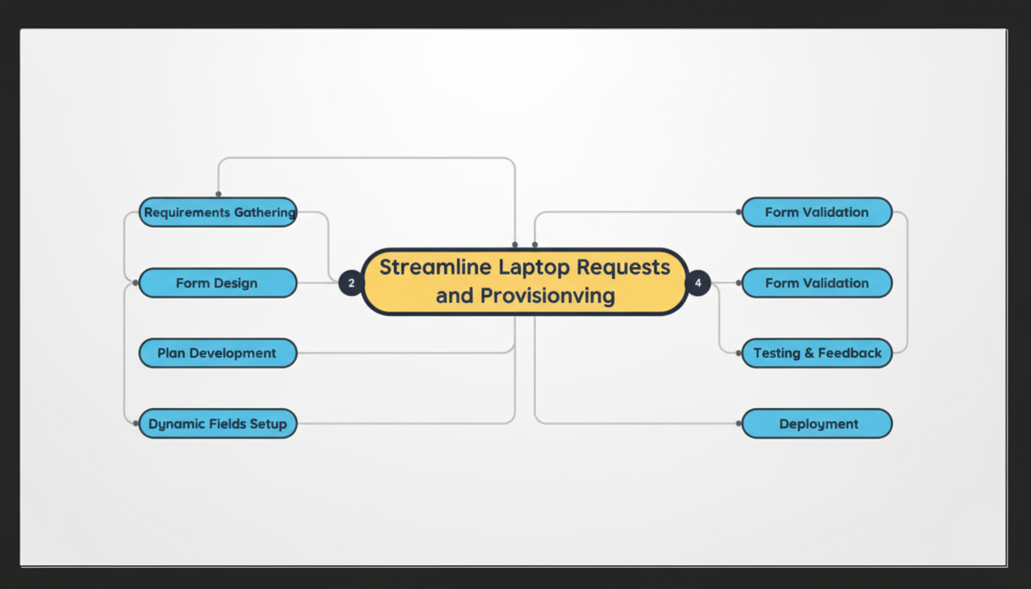

References for Approach
- Problem-Solution Fit Canvas - IdeaHackers Network
- Medium: Problem-Solution Fit Canvas

